1- Write a C program to check whether an alphabet is vowel or

consonant using if else.

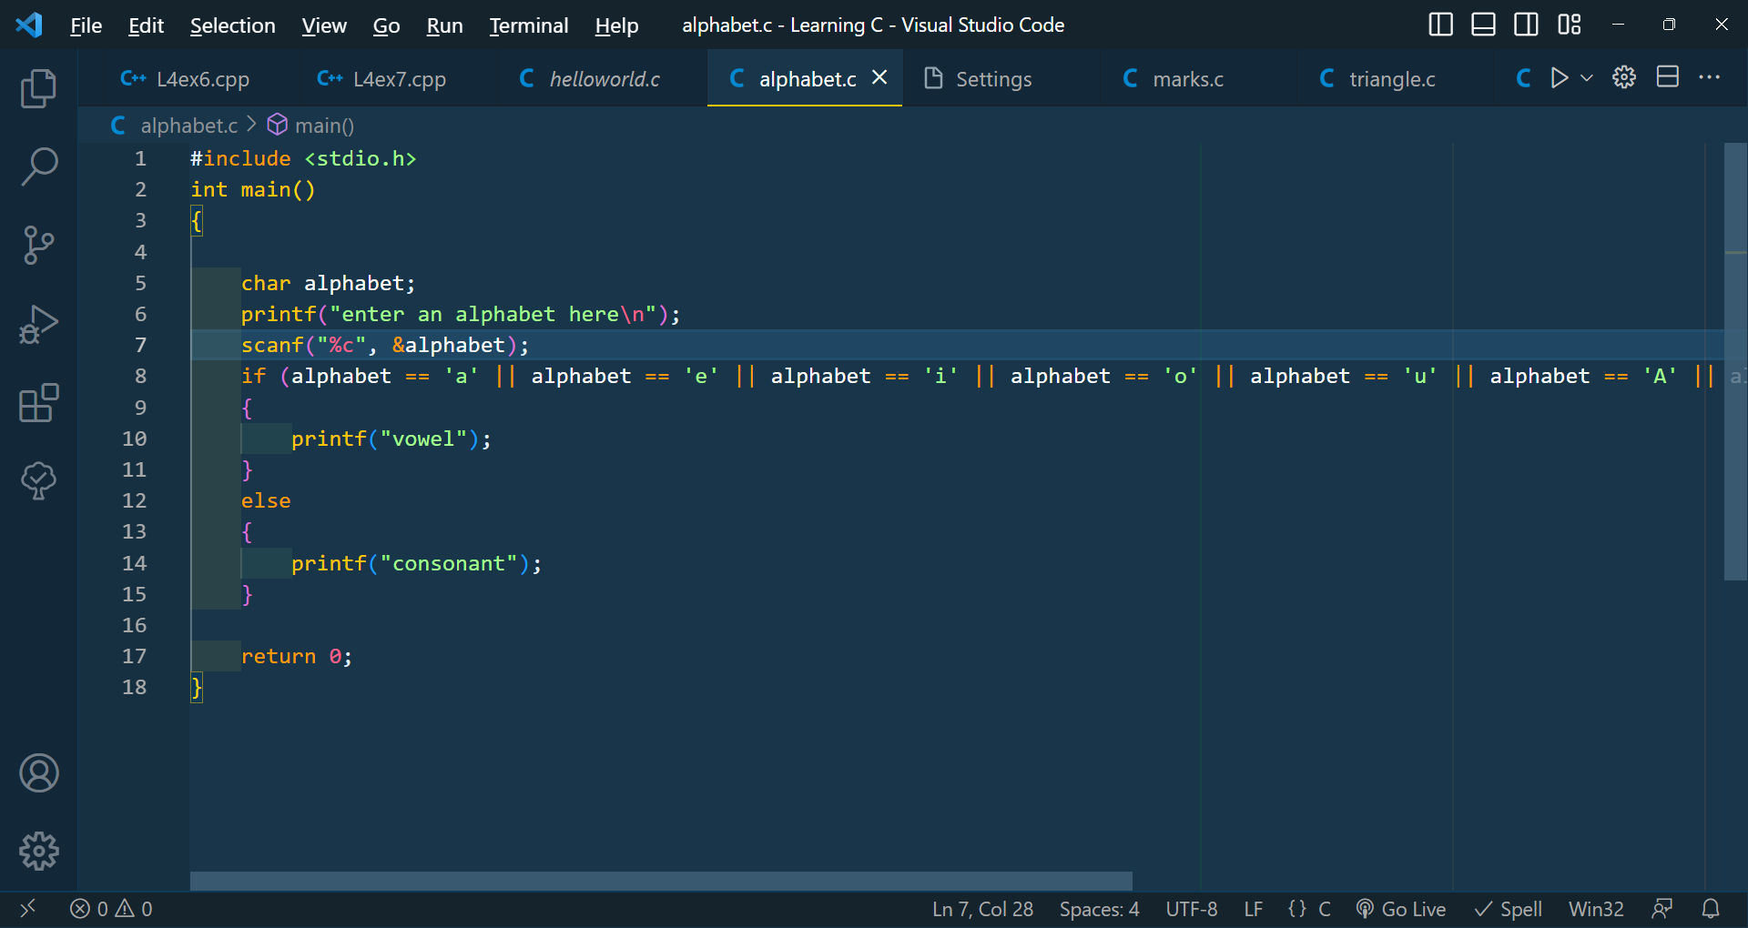

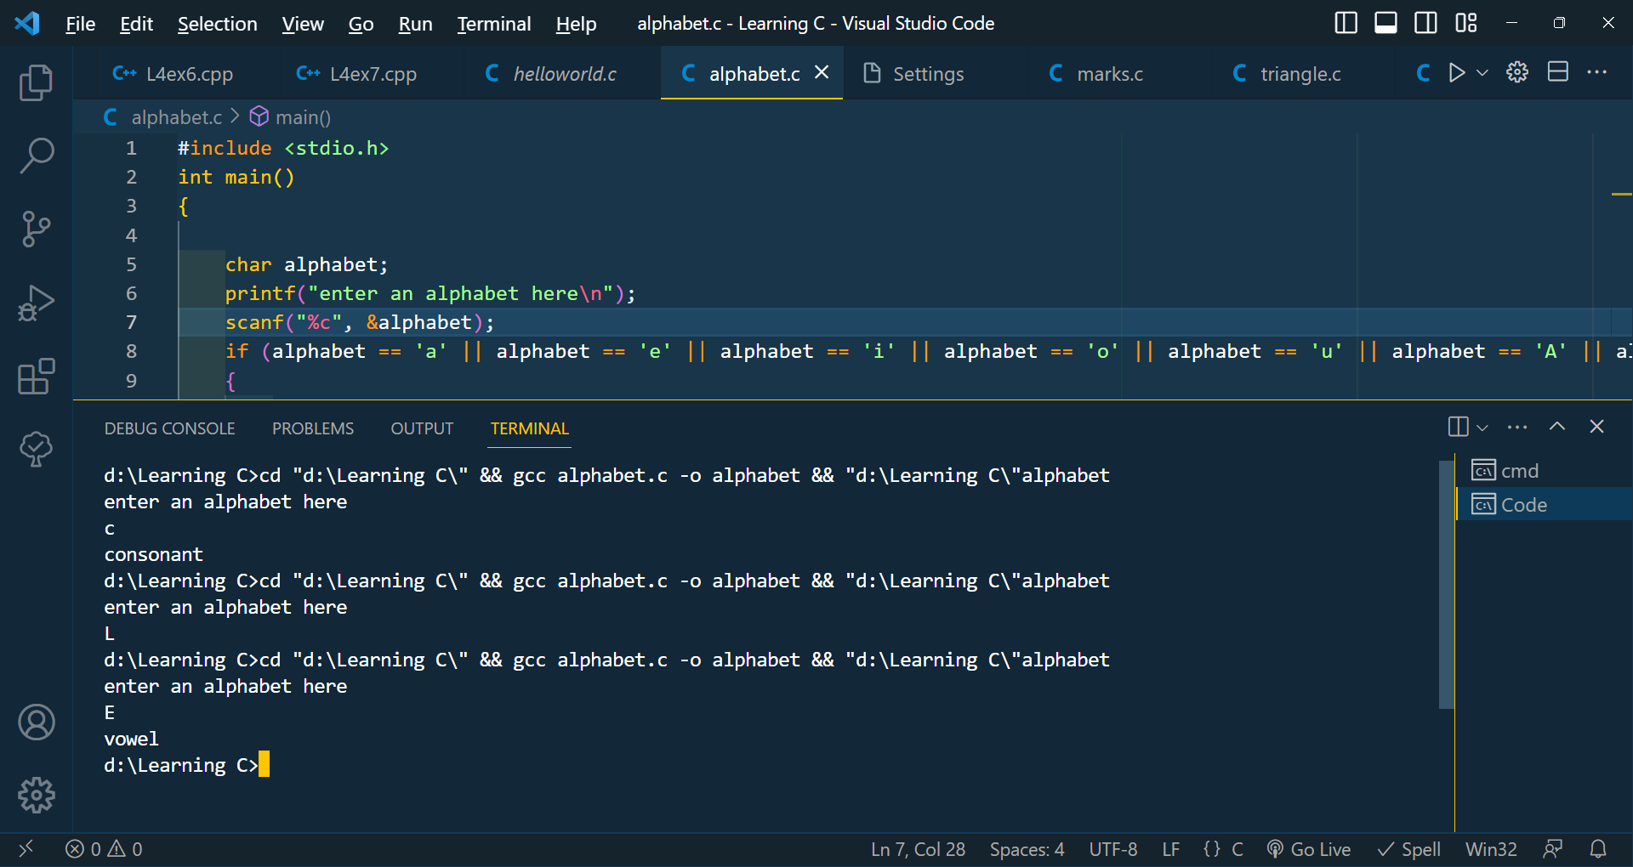

2- Write a C program to input marks for five subjects Physics,

Chemistry, Biology, Mathematics, and Computer. Calculate the

percentage and grade according to the following:

Percentage >= 90% : Grade A

Percentage >= 80% : Grade B

Percentage >= 70% : Grade C

Percentage >= 60% : Grade D

Percentage >= 40% : Grade E

Percentage < 40% : Grade F

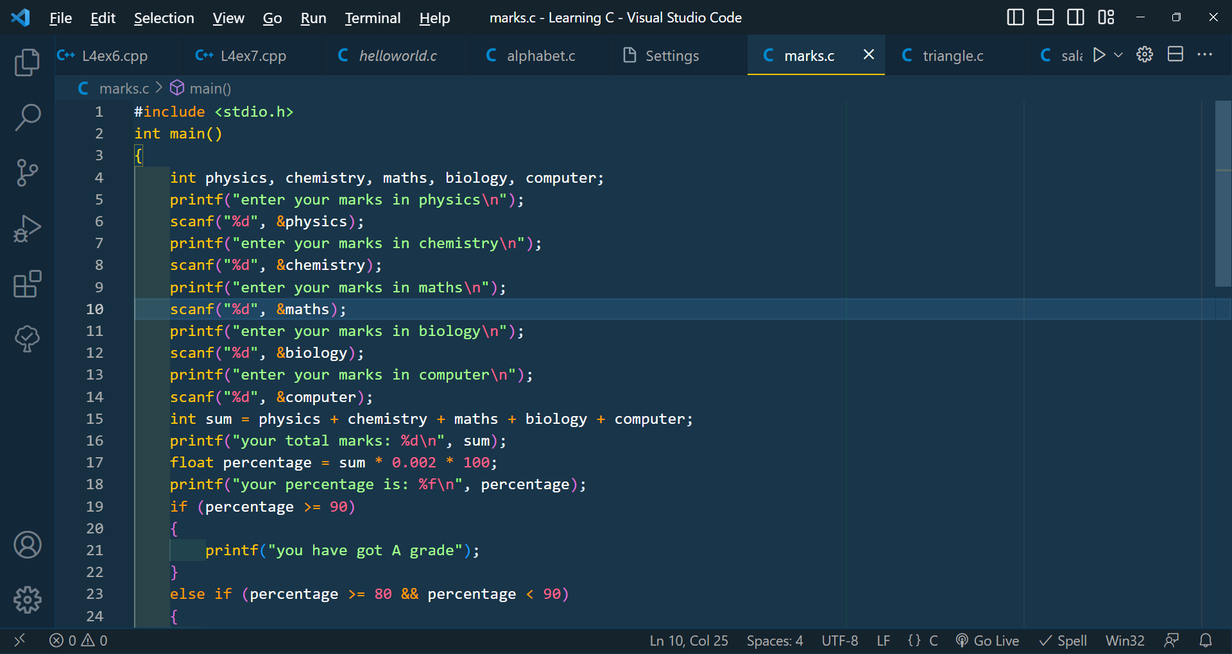

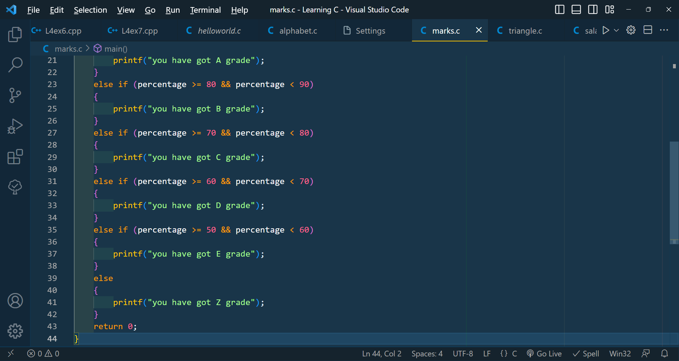

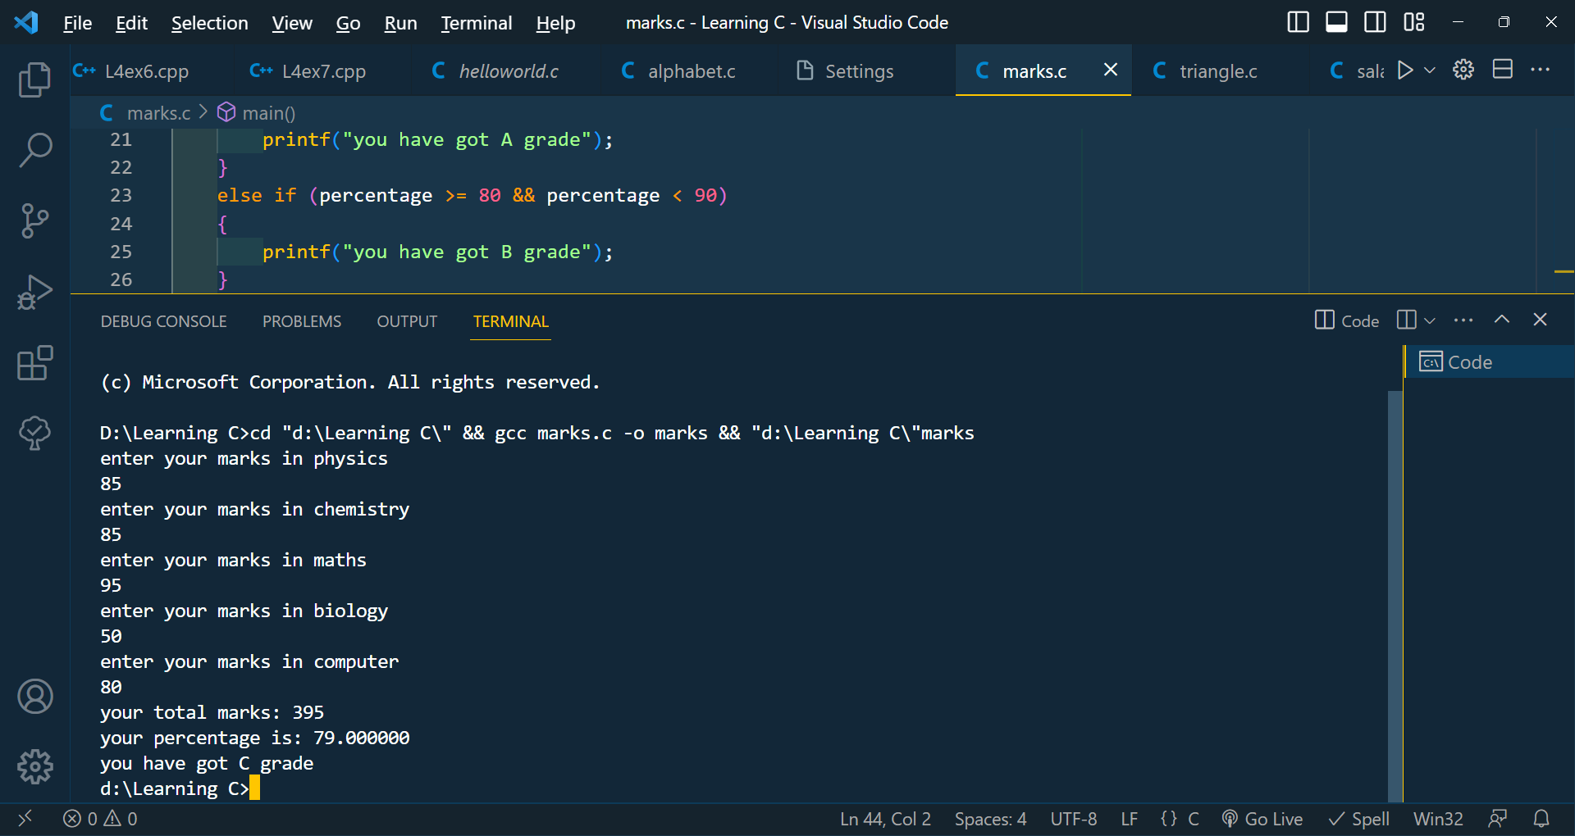

3- Write a C program to input the electricity unit charge and calculate

the total electricity bill according to the given condition:

For the first 50 units Rs. 0.50/unit

For next 100 units Rs. 0.75/unit

For next 100 units Rs. 1.20/unit

For units above 250 Rs. 1.50/unit

An additional surcharge of 20% is added to the bill.

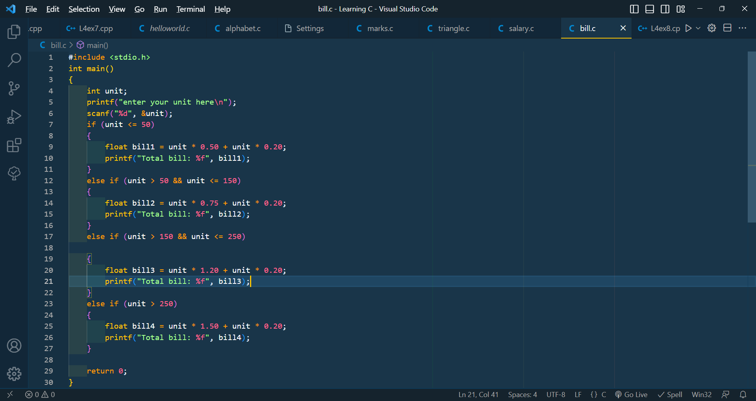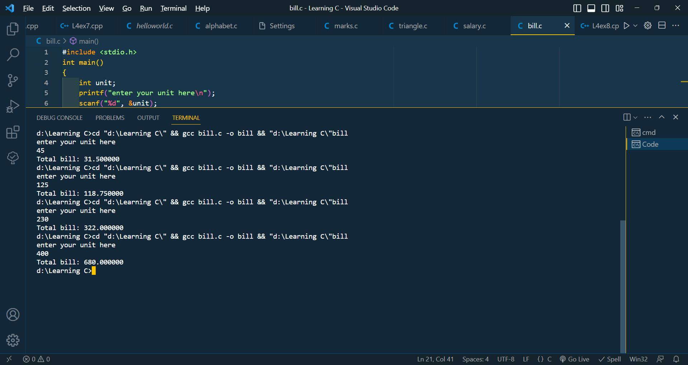

4- Write a C program to input the side of a triangle and check whether

the triangle is valid or not using if else.

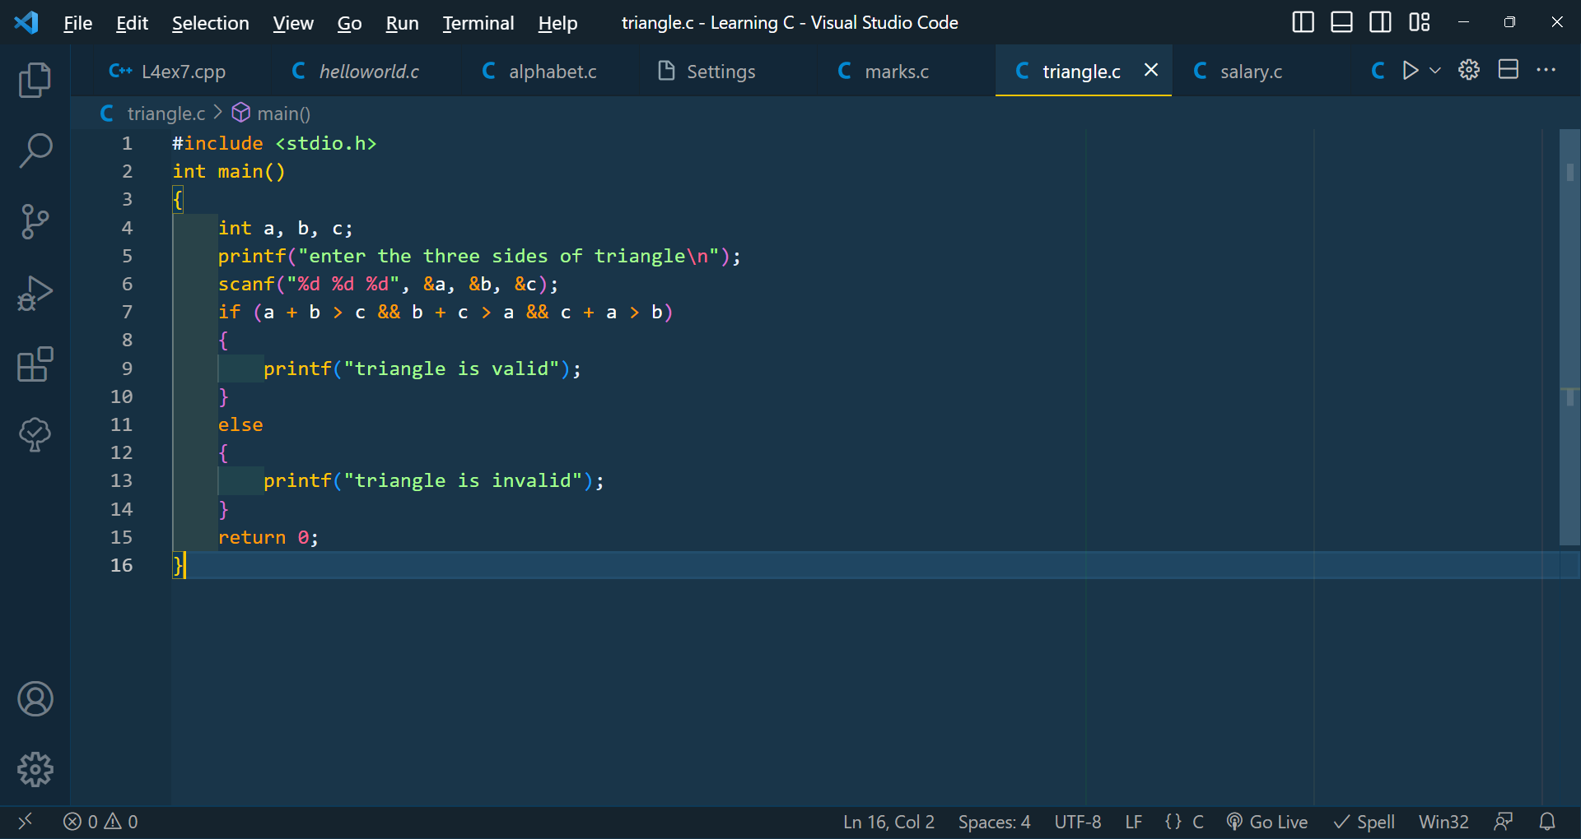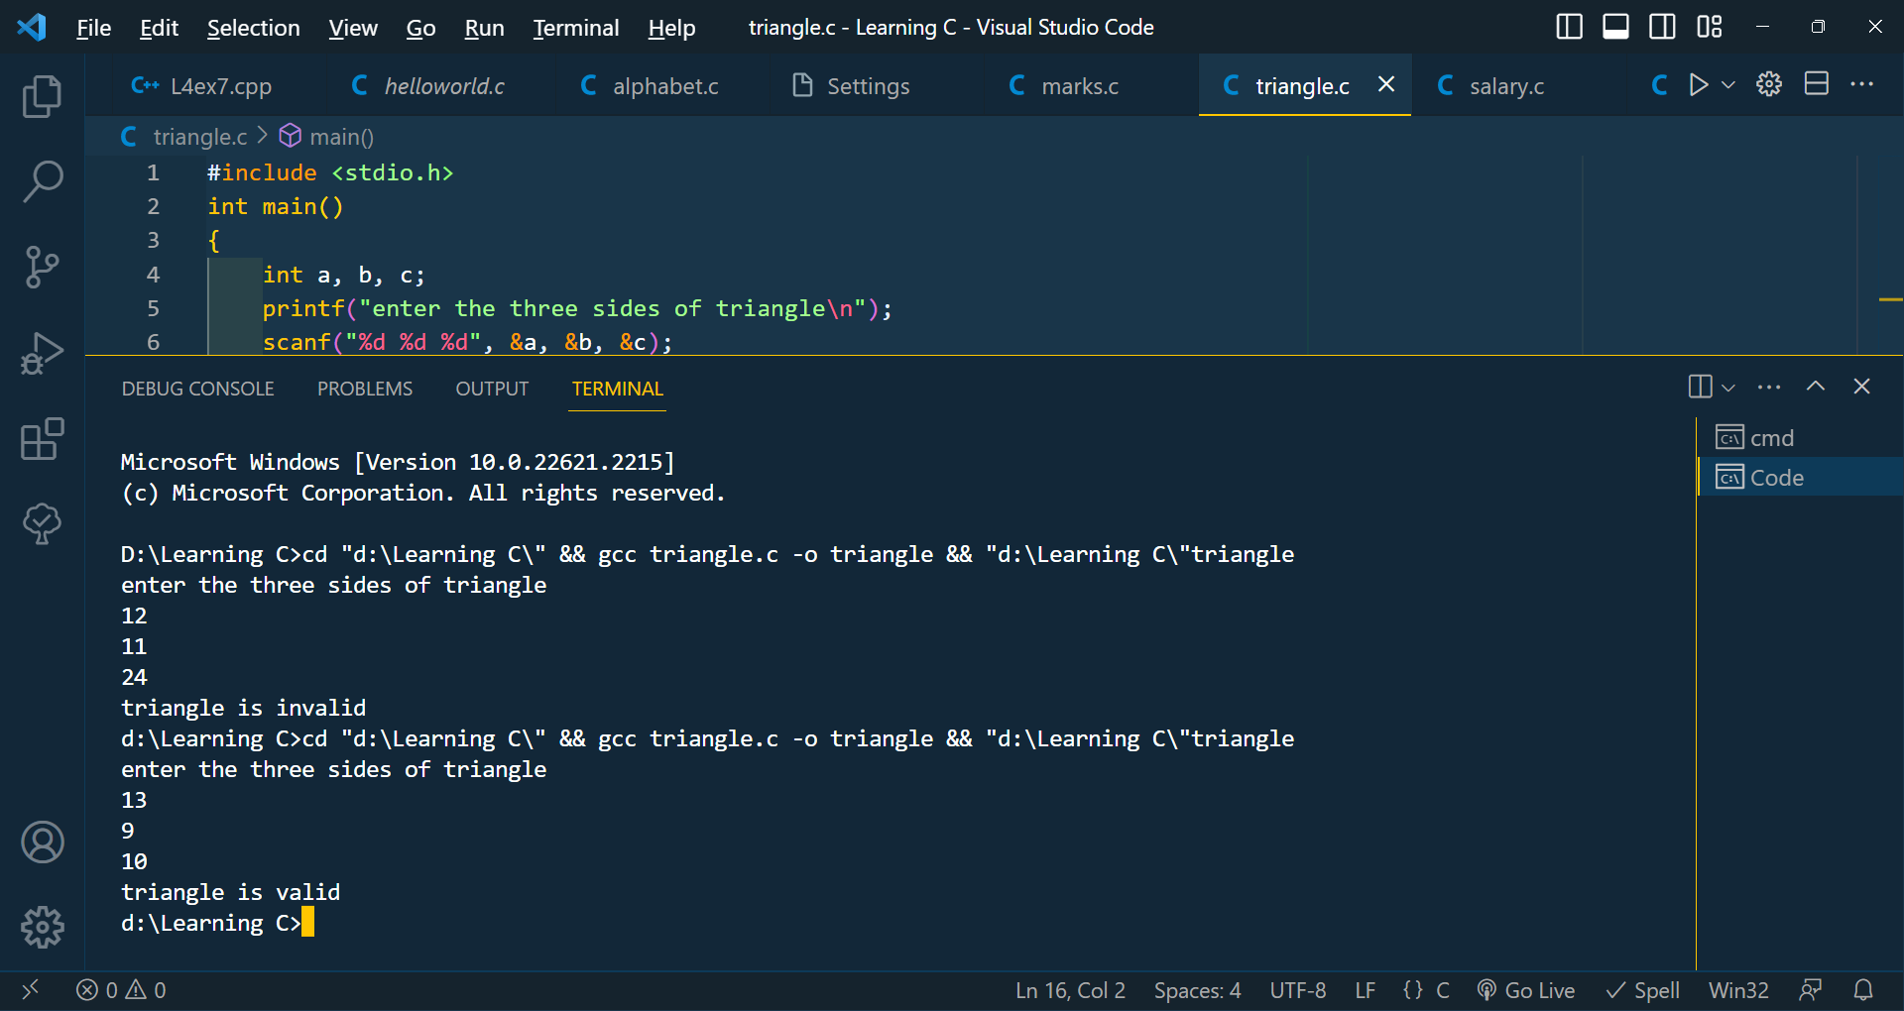

5- Write a C program to input the basic salary of an employee and

calculate gross salary according to given conditions.

Basic Salary <= 10000 : HRA = 20%, DA = 80%

Basic Salary is between 10001 to 20000 : HRA = 25%, DA = 90%

Basic Salary >= 20001 : HRA = 30%, DA = 95%

